Student’s name | …………………………………………………….…… | Grade | 7
Subject | Computer | Week No. | 8
Lesson Title | Cryptography | Unit
Worksheet No. ( 8 ) (Answer)
Question A: write the correct name of each part.

Encryption | Plain Text | Algorithm | Cipher Text

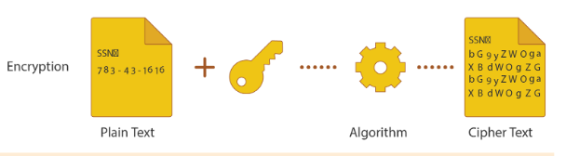
Good Luck

